**U.S. Office of Special Counsel**

1730 M Street NW, Suite 218

Washington, DC 20036-4505

(202) 804-7163 [certification@osc.gov](mailto:certification@osc.gov)

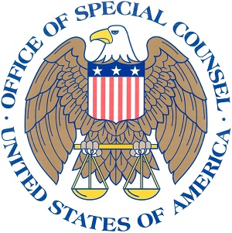

The U.S. Office of Special Counsel's (OSC) Certification Program allows federal agencies to meet the statutory obligations of 5 U.S.C. § 2302(c), the Dr. Chris Kirkpatrick Whistleblower Protection Act, and the Office of Special Counsel Reauthorization Act of 2017. In addition to the existing requirements of the program, these statutes require agency heads to ensure that their employees receive yearly information about whistleblower protection laws and to provide annual *supervisory* training on how to respond to complaints involving whistleblower protections. Certified agencies must complete this checklist each year to ensure their compliance with ongoing and new annual requirements. The completed checklist should be emailed to certification@osc.gov. Questions about completing this form should be directed to OSC’s Diversity, Outreach, and Training Unit, which can be reached at 202-804-7163 or [certification@osc.gov](mailto:certification@osc.gov).

General Information

**Agency or Office Completing Checklist:** Click or tap here to enter text.

Agency and OIG

Agency

OIG

Component (please indicate parent agency) Click or tap here to enter text.

Contact Information

Please provide the contact information for the official responsible for implementing OSC's Certification Program (the individual’s name and phone number will be placed on OSC’s website as the point of contact once the agency is certified).

Name: Click or tap here to enter text.

Title: Click or tap here to enter text.

Email: Click or tap here to enter text.

Phone: Click or tap here to enter text.

Address (to send certificate): Click or tap here to enter text.

**U.S. Office of Special Counsel’s**

**Annual Certification Checklist**

1. Verified that the agency has the most current OSC posters on display throughout the agency

2. Confirmed that new employees received information on PPPs and whistleblower disclosures within 180 days of employment (OSC handouts)

3. Disseminated (by head of agency or designee) annual notification to all employees emphasizing the importance of whistleblower protection laws and including links to educational information on PPPs and whistleblower disclosures (OSC handouts)

4. Trained supervisors on how to respond to complaints alleging a violation of whistleblower protections (OSC in-person or virtual training or PowerPoint presentation)

5. Checked the links to OSC’s website on both the agency’s website and intranet

6. Ensured that the agency has identified means for disclosing classified information or information prohibited from release by law to the: (I) Special Counsel; (II) the Inspector General of an agency; (III) Congress; or (IV) another employee of the agency who is designated to receive such disclosures.

Comments (optional): Click or tap here to enter text.

Requirement Checklist Information

Signature of official responsible for implementing OSC’s Certification Program:



Confirmation of Completion